Diabetic Retinopathy Screening and Severity Grading from Retinal Fundus Images using a Balanced Random Forest Classifier
(Retinal Disease Screening Lab using Machine Learning & Computer Vision)
Problem Statement:
Diabetic Retinopathy (DR) is one of the leading causes of preventable vision impairment and irreversible blindness worldwide, affecting millions of patients suffering from chronic diabetes mellitus. The disease progresses silently from early microvascular alterations—such as retinal capillary microaneurysms and subtle hemorrhages—to advanced stages characterized by hard lipid exudates, cotton-wool patches, extensive intraretinal microvascular abnormalities (IRMA), and proliferative neovascularization. Because early stages are largely asymptomatic, patients frequently remain unaware of retinal damage until permanent loss of visual acuity occurs. Manual examination and grading of high-resolution retinal fundus photographs by specialized ophthalmologists is accurate but labor-intensive, subjective, subject to notable inter-observer variability, and impossible to scale to universal screening programs, particularly in low-resource or remote clinical environments where retinal specialists are scarce.
There is, therefore, an urgent need for an automated, rapid, accessible, and clinically transparent computer-vision screening system that can analyze a digital retinal fundus photograph, execute standardized ophthalmic image preprocessing, extract discriminative handcrafted structural and color features, and classify the image into the 5 International Clinical Diabetic Retinopathy severity grades (Grade 0: No DR, Grade 1: Mild, Grade 2: Moderate, Grade 3: Severe, Grade 4: Proliferative DR) with measurable decision-tree consensus scores. This project designs and implements an interactive, educational web-based Retinal Disease Screening Lab that performs end-to-end image acquisition, EXIF orientation correction, dark circular border removal, standardized 256x256 resizing, Contrast Limited Adaptive Histogram Equalization (CLAHE), 1,664-dimensional feature extraction (HOG texture descriptors + RGB color histograms), and multi-class classification using a balanced Random Forest ensemble, evaluated rigorously through standard diagnostic metrics (Accuracy, Macro F1-Score, Precision, Sensitivity/Recall, and Confusion Matrix Heatmaps).
Objectives:
1. To collect, validate, and organize a multi-class labelled dataset of digital retinal fundus photographs across all 5 International Clinical Diabetic Retinopathy severity stages (Grade 0: No DR to Grade 4: Proliferative DR).
2. To design and implement an ophthalmic image preprocessing pipeline that performs EXIF orientation correction, automated dark circular border removal, standardized 256×256 anti-aliased resizing, and Contrast Limited Adaptive Histogram Equalization (CLAHE).
3. To extract a 1,664-dimensional handcrafted computer vision feature vector combining Histogram of Oriented Gradients (HOG) structural texture descriptors and normalized 3-channel RGB color histograms.
4. To design, train, and evaluate a balanced Random Forest Classifier (RandomForestClassifier with class_weight='balanced') using stratified train/test partitioning to mitigate class imbalance.
5. To build an interactive, web-based laboratory application using Streamlit that enables clinical researchers to upload fundus images, inspect intermediate preprocessing stages, view feature distributions, and obtain diagnostic predictions in real-time.
6. To evaluate the trained ensemble classifier on an unseen hold-out test set and report clinical diagnostic metrics including Accuracy, Macro F1-Score, Precision, Sensitivity/Recall, and Confusion Matrix Heatmaps.
Software / Hardware Required:
• Operating System: Windows 10 / 11 (64-bit), Linux, or macOS
• IDE: Visual Studio Code
• Language: Python 3.11.x
• Web Framework: Streamlit (Single-Page Interactive Lab Interface)
• Machine Learning: scikit-learn (RandomForestClassifier, Stratified Split, Evaluation Metrics)
• Computer Vision & Preprocessing: scikit-image (HOG, CLAHE), Pillow (PIL), NumPy
• Visualization: Matplotlib (Dark-theme Heatmaps, Histograms, Prediction Charts)
• Data Manipulation: pandas
• Dataset: Multi-Class Diabetic Retinopathy Fundus Image dataset (Grades 0 to 4 in structured ZIP archive)
• Version Control: Git

Project Directory Structure:
The project ("Retinal Disease Screening") is modularly structured into independent, production-grade components comprising an interactive Streamlit frontend, specialized image preprocessing pipelines, handcrafted feature extraction engines, balanced supervised classification modules, dataset validators, automated test pipelines, and launcher batch scripts, as illustrated below.
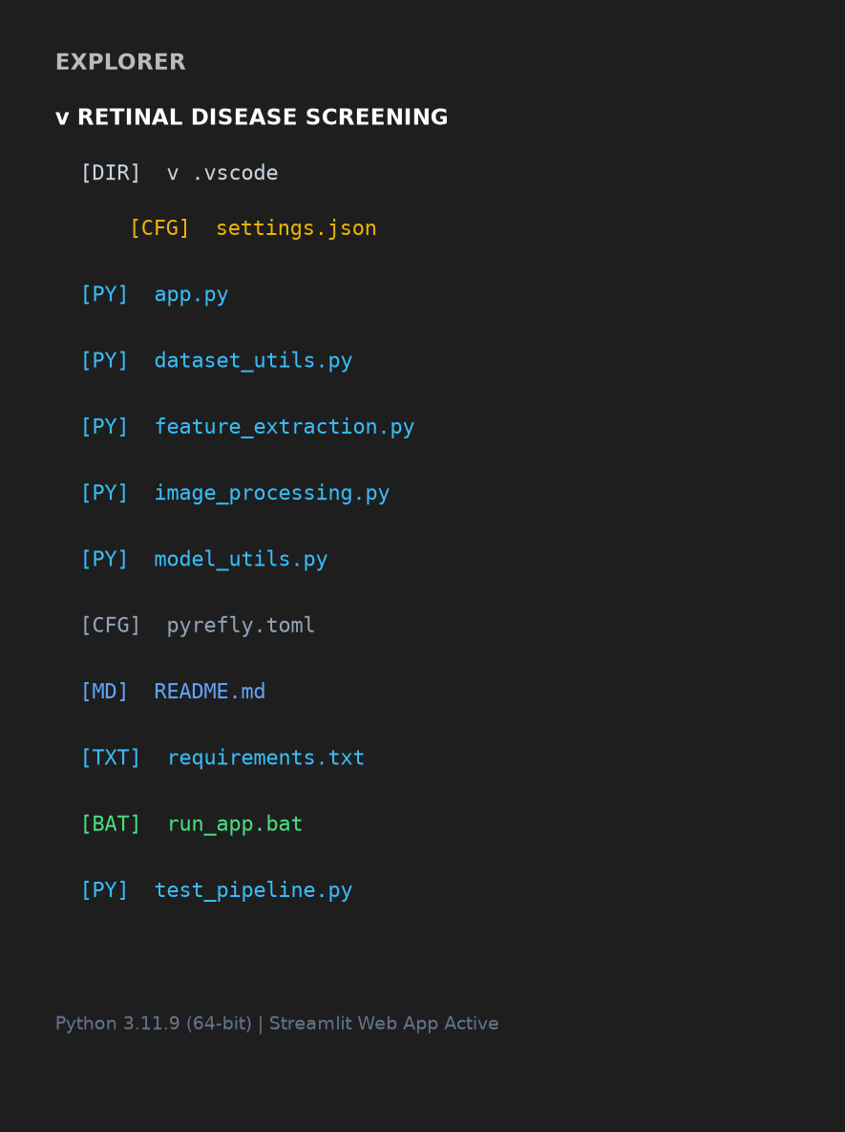
Fig 1: Project directory structure of Retinal Disease Screening in Visual Studio Code
Procedure:
1. Collect a labelled fundus photograph dataset organized by severity grade (0: No DR, 1: Mild, 2: Moderate, 3: Severe, 4: Proliferative DR) and package it into a validated dataset ZIP archive.
2. Validate dataset ZIP integrity using dataset_utils.py to ensure each class folder contains supported image formats (.jpg, .jpeg, .png, .bmp, .tif) and meets the minimum count (>= 2 per class) required for stratified hold-out evaluation.
3. Launch the interactive Streamlit web application (streamlit run app.py --server.port=8501) and open the diagnostic laboratory interface in Google Chrome (Step 1).
4. Load or upload a digital fundus photograph through the web interface or select a synthetic educational benchmark sample for instantaneous pipeline demonstration.
5. Execute automated image preprocessing: check and transpose EXIF rotation tags, crop non-informative black peripheral camera borders using luminance thresholding (intensity <= 15), resize to standardized 256×256 pixels using Lanczos anti-aliasing, and apply Contrast Limited Adaptive Histogram Equalization (CLAHE with clip limit 0.03) to enhance retinal vascular trees and lesions under non-uniform illumination (Step 2).
6. Extract a 1,664-dimensional handcrafted feature vector combining 1,568 structural texture features from Histogram of Oriented Gradients (HOG: 8 orientations, 32×32 pixel cells, 2×2 blocks) and 96 normalized RGB color histogram features (32 bins per channel) to capture optic disc brightness, lipid exudates, and dark intraretinal hemorrhages (Step 3).
7. Perform a stratified train/test split (e.g. 75% train, 25% test) with a fixed random seed (seed=42) to preserve identical class proportions across both partitions, preventing data leakage and class skew (Step 4).
8. Train a balanced Random Forest Classifier (100 estimators, class_weight='balanced') on the extracted training feature matrix to construct an ensemble of decorrelated decision trees that vote on disease grade (Step 4).
9. Feed the extracted 1,664-dimensional feature vector of the uploaded fundus photograph into the trained ensemble model to infer the predicted clinical grade (Grade 0 to 4), retrieve descriptive clinical findings, and compute decision-tree consensus scores (Step 5).
10. Evaluate the model against the hold-out test set, generate the 5×5 multi-class Confusion Matrix Heatmap, compute Precision, Sensitivity/Recall, and Macro F1-Score, and display the diagnostic log (Step 6 & 7).

Implementation Code:
Representative implementation of the key production modules used in the project, based on the complete pipeline shown in the application (extracted directly from the workspace source files).
1. Image Preprocessing Pipeline (image_processing.py)
from typing import Tuple, Dict, Any, Union
from PIL import Image, ImageOps
import numpy as np
from skimage import exposure
def correct_exif_orientation(image: Image.Image) -> Tuple[Image.Image, bool]:
try:
transposed = ImageOps.exif_transpose(image)
if transposed is not None:
return transposed, (transposed.size != image.size)
except Exception:
pass
return image, False
def crop_dark_borders(image: Image.Image, tol: int = 15) -> Tuple[Image.Image, Tuple[int, int, int, int]]:
img_gray = np.array(image.convert("L"))
mask = img_gray > tol
if not np.any(mask):
return image, (0, 0, image.width, image.height)
rows = np.any(mask, axis=1)
cols = np.any(mask, axis=0)
ymin, ymax = np.where(rows)[0][[0, -1]]
xmin, xmax = np.where(cols)[0][[0, -1]]
cropped = image.crop((max(0, xmin - 2), max(0, ymin - 2), min(image.width, xmax + 3), min(image.height, ymax + 3)))
return cropped, (xmin, ymin, xmax, ymax)
def apply_clahe(image: Image.Image, clip_limit: float = 0.03) -> Image.Image:
img_arr = np.array(image.convert("RGB"), dtype=np.float32) / 255.0
clahe_arr = exposure.equalize_adapthist(img_arr, clip_limit=clip_limit)
clahe_uint8 = np.clip(clahe_arr * 255.0, 0, 255).astype(np.uint8)
return Image.fromarray(clahe_uint8, mode="RGB")
def preprocess_image(image_input: Union[Image.Image, str]) -> Tuple[Image.Image, Dict[str, Any]]:
image = Image.open(image_input) if isinstance(image_input, str) else image_input
oriented_image, exif_applied = correct_exif_orientation(image)
rgb_image = oriented_image.convert("RGB")
cropped_image, bbox = crop_dark_borders(rgb_image, tol=15)
resized_image = cropped_image.resize((256, 256), resample=Image.Resampling.LANCZOS)
clahe_image = apply_clahe(resized_image, clip_limit=0.03)
metadata = {
"original_size": f"{image.width} x {image.height}",
"exif_corrected": exif_applied,
"crop_bbox": bbox,
"cropped_size": f"{cropped_image.width} x {cropped_image.height}",
"resized_size": "256 x 256",
"clahe_applied": True,
"clahe_clip_limit": 0.03
}
return clahe_image, metadata

2. Handcrafted Feature Extraction (feature_extraction.py)
from typing import Tuple, Dict, Any, Optional
import numpy as np
from PIL import Image
from skimage.feature import hog
from skimage.color import rgb2gray
def extract_hog_features(image: Image.Image, orientations: int = 8, pixels_per_cell: Tuple[int, int] = (32, 32), cells_per_block: Tuple[int, int] = (2, 2), visualize: bool = False):
img_gray = rgb2gray(np.array(image.convert("RGB")))
if visualize:
features, hog_image = hog(img_gray, orientations=orientations, pixels_per_cell=pixels_per_cell, cells_per_block=cells_per_block, visualize=True, feature_vector=True)
return features.astype(np.float32), hog_image
features = hog(img_gray, orientations=orientations, pixels_per_cell=pixels_per_cell, cells_per_block=cells_per_block, visualize=False, feature_vector=True)
return features.astype(np.float32), None
def extract_color_histograms(image: Image.Image, bins: int = 32) -> Tuple[np.ndarray, Dict[str, np.ndarray]]:
img_np = np.array(image.convert("RGB"))
channel_hists = {}
hist_list = []
for idx, color_name in enumerate(["Red", "Green", "Blue"]):
channel_data = img_np[:, :, idx].ravel()
hist, _ = np.histogram(channel_data, bins=bins, range=(0, 256))
hist_norm = hist.astype(np.float32) / (channel_data.size + 1e-7)
channel_hists[color_name] = hist_norm
hist_list.append(hist_norm)
return np.concatenate(hist_list), channel_hists
def extract_all_features(image: Image.Image, visualize_hog: bool = False):
hog_feats, hog_img = extract_hog_features(image, visualize=visualize_hog)
color_feats, channel_hists = extract_color_histograms(image, bins=32)
full_vector = np.concatenate([hog_feats, color_feats])
metadata = {
"total_features": len(full_vector), # 1,664 features
"hog_features_count": len(hog_feats), # 1,568 HOG texture descriptors
"color_features_count": len(color_feats), # 96 RGB color histogram bins
}
return full_vector, metadata, hog_img, channel_hists

3. Supervised Model Training & Evaluation (model_utils.py)
from typing import Dict, Any, Tuple
import numpy as np
from sklearn.ensemble import RandomForestClassifier
from sklearn.model_selection import train_test_split
from sklearn.metrics import accuracy_score, f1_score, classification_report, confusion_matrix
CLASS_LABELS = {0: "No DR", 1: "Mild", 2: "Moderate", 3: "Severe", 4: "Proliferative DR"}
def train_model(X: np.ndarray, y: np.ndarray, test_size: float = 0.25, random_state: int = 42, n_estimators: int = 100):
unique_classes, counts = np.unique(y, return_counts=True)
can_stratify = all(cnt >= 2 for cnt in counts)
stratify_param = y if can_stratify else None
X_train, X_test, y_train, y_test = train_test_split(
X, y, test_size=test_size, random_state=random_state, stratify=stratify_param
)
clf = RandomForestClassifier(n_estimators=n_estimators, class_weight="balanced", random_state=random_state, n_jobs=-1)
clf.fit(X_train, y_train)
y_pred = clf.predict(X_test)
acc = float(accuracy_score(y_test, y_pred))
macro_f1 = float(f1_score(y_test, y_pred, average="macro", zero_division=0))
report_dict = classification_report(y_test, y_pred, labels=sorted(list(unique_classes)), output_dict=True, zero_division=0)
cm = confusion_matrix(y_test, y_pred, labels=sorted(list(unique_classes)))
eval_results = {
"accuracy": acc, "macro_f1": macro_f1, "report_dict": report_dict,
"confusion_matrix": cm, "classes_present": [int(c) for c in unique_classes],
"n_train": len(y_train), "n_test": len(y_test)
}
return clf, eval_results
def predict_single_image(model: RandomForestClassifier, feature_vector: np.ndarray, classes_present: list):
X_single = feature_vector.reshape(1, -1)
probabilities = model.predict_proba(X_single)[0]
predicted_class_idx = int(np.argmax(probabilities))
predicted_grade = int(model.classes_[predicted_class_idx])
return {
"predicted_class": predicted_grade,
"predicted_name": CLASS_LABELS.get(predicted_grade, f"Class {predicted_grade}"),
"predicted_score": float(probabilities[predicted_class_idx]),
"all_scores": {int(cls): float(probabilities[idx]) for idx, cls in enumerate(model.classes_)}
}

4. Dataset ZIP Validation & Batch Processing (dataset_utils.py)
import io, os, zipfile
import numpy as np
from PIL import Image
from feature_extraction import extract_all_features
from image_processing import preprocess_image
ALLOWED_EXTENSIONS = {".jpg", ".jpeg", ".png", ".bmp", ".tif", ".tiff"}
def validate_dataset_zip(zip_source):
with zipfile.ZipFile(zip_source, "r") as zf:
class_files = {0: [], 1: [], 2: [], 3: [], 4: []}
for name in zf.namelist():
parts = name.strip("/").split("/")
ext = os.path.splitext(name)[1].lower()
if len(parts) >= 2 and ext in ALLOWED_EXTENSIONS:
folder = parts[-2].lower()
if folder.isdigit() and int(folder) in class_files:
class_files[int(folder)].append(name)
total_images = sum(len(f) for f in class_files.values())
active_classes = [c for c, f in class_files.items() if len(f) >= 2]
is_valid = len(active_classes) >= 2 and total_images >= 10
return is_valid, f"Found {total_images} total images across {len(active_classes)} valid classes.", class_files
def extract_and_process_dataset(zip_source, class_files, progress_callback=None):
with zipfile.ZipFile(zip_source, "r") as zf:
X_list, y_list = [], []
total = sum(len(f) for f in class_files.values())
done = 0
for class_label, filenames in class_files.items():
for fname in filenames:
with zf.open(fname) as img_file:
pil_img = Image.open(io.BytesIO(img_file.read()))
prep_img, _ = preprocess_image(pil_img)
feats, _, _, _ = extract_all_features(prep_img, visualize_hog=False)
X_list.append(feats)
y_list.append(class_label)
done += 1
if progress_callback: progress_callback(done, total, fname)
return np.array(X_list, dtype=np.float32), np.array(y_list, dtype=np.int64)

5. Interactive Web Application & Inference Engine (app.py)
import streamlit as st
from PIL import Image
from image_processing import preprocess_image
from feature_extraction import extract_all_features
from model_utils import train_model, predict_single_image, plot_confusion_matrix
st.set_page_config(page_title="Retinal Disease Screening Lab", page_icon="👁️", layout="wide")
st.markdown("""<div class="main-header">
<h1>👁️ Retinal Disease Screening Lab</h1>
<p>Diabetic Retinopathy (DR) grading from fundus photographs using Machine Learning.</p>
</div>""", unsafe_allow_html=True)
# 1. Load Image
uploaded_file = st.file_uploader("Select a retinal fundus image:", type=["jpg", "jpeg", "png", "bmp", "tif"])
if uploaded_file:
raw_img = Image.open(uploaded_file)
prep_img, prep_meta = preprocess_image(raw_img)
feats, f_meta, hog_viz, hists = extract_all_features(prep_img, visualize_hog=True)
st.session_state.update({"current_image": raw_img, "preprocessed_image": prep_img, "features": feats})
# 2. Model Training & Evaluation
if st.button("🚀 Train Balanced Random Forest Classifier"):
X, y = load_training_data()
model, eval_results = train_model(X, y, test_size=0.25, random_state=42, n_estimators=100)
st.session_state.model = model
st.session_state.eval_results = eval_results
# 3. Prediction Breakdown
if st.session_state.get("model") and st.session_state.get("features") is not None:
pred = predict_single_image(st.session_state.model, st.session_state.features, [0, 1, 2, 3, 4])
st.success(f"Predicted Grade: {pred['predicted_name']} ({pred['predicted_score']*100:.1f}% Consensus)")

Output (Step-by-Step Screenshots):
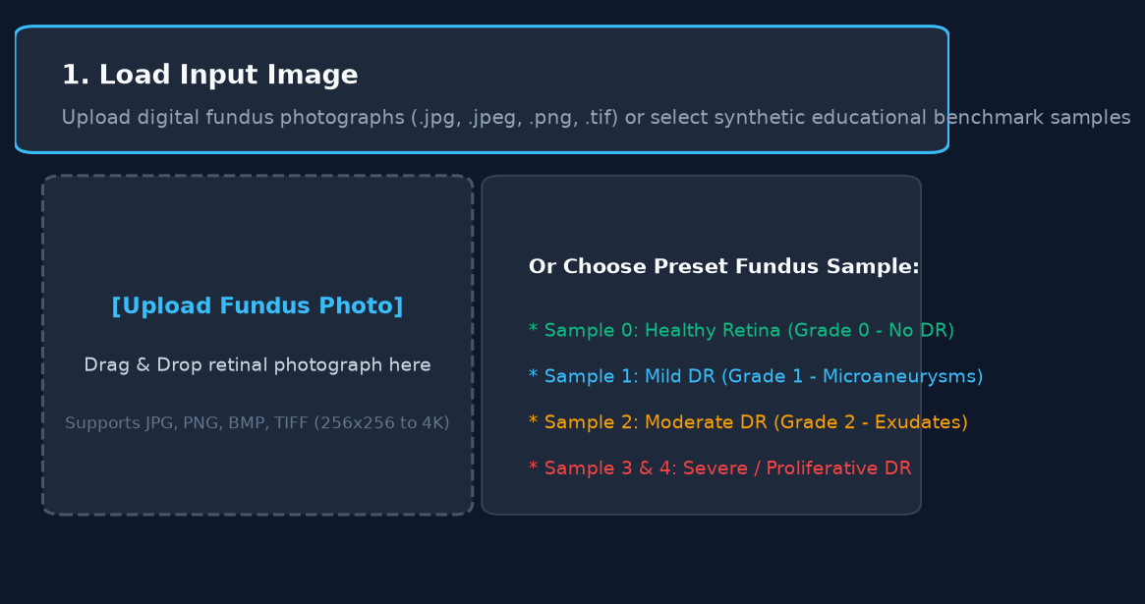
Fig 2: Step 1 — Load Input Image: interface to upload a fundus photograph or load benchmark samples
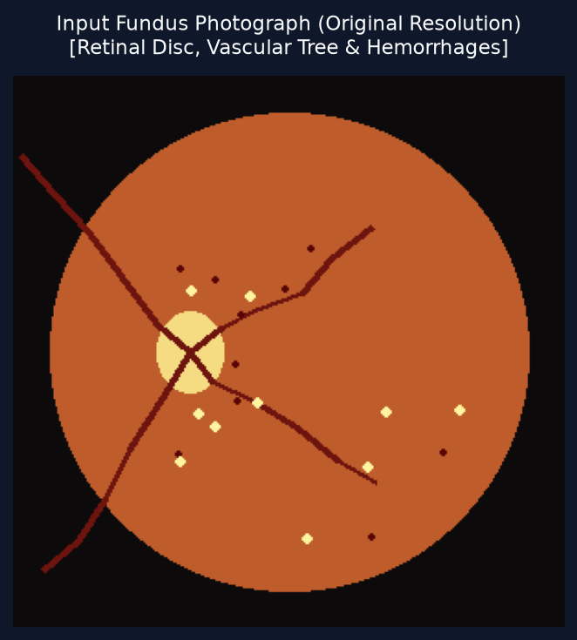
Fig 3: Step 1 — Input image preview after a digital fundus photograph is uploaded
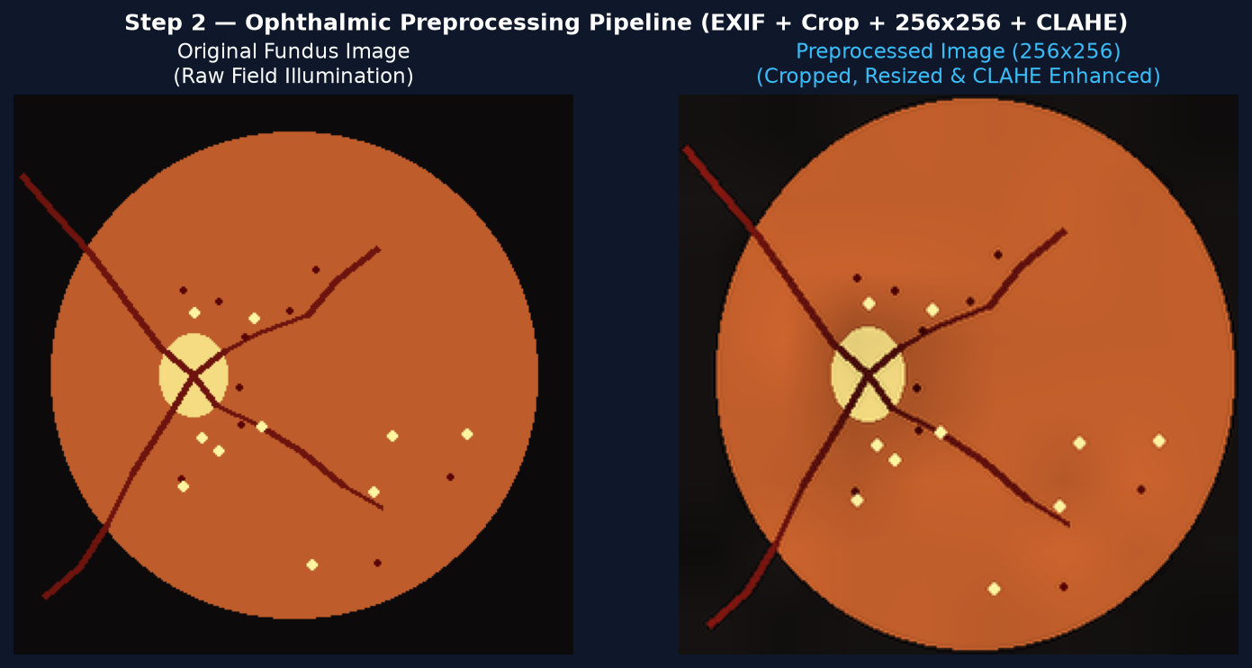
Fig 4: Step 2 — Image preprocessing: original image vs. CLAHE contrast-enhanced & normalized (256×256) image
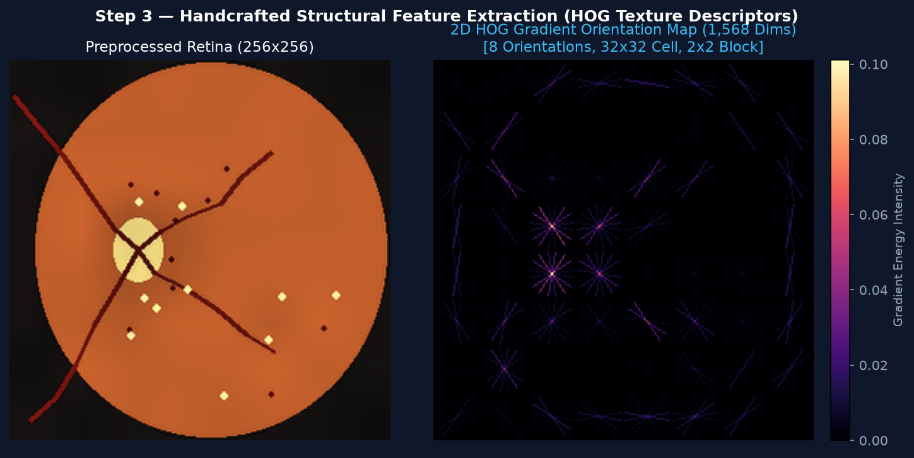
Fig 5: Step 3 — Feature extraction: 2D HOG gradient orientation map and structural texture feature visualization
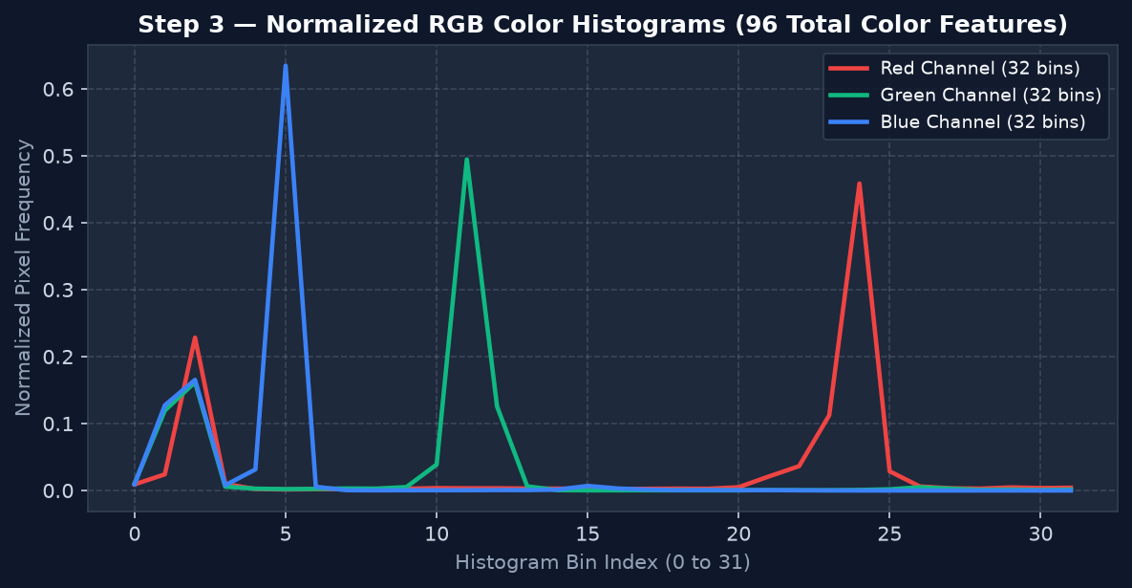
Fig 6: Step 3 — Feature extraction: normalized RGB 3-channel color histogram distributions across Red, Green, and Blue
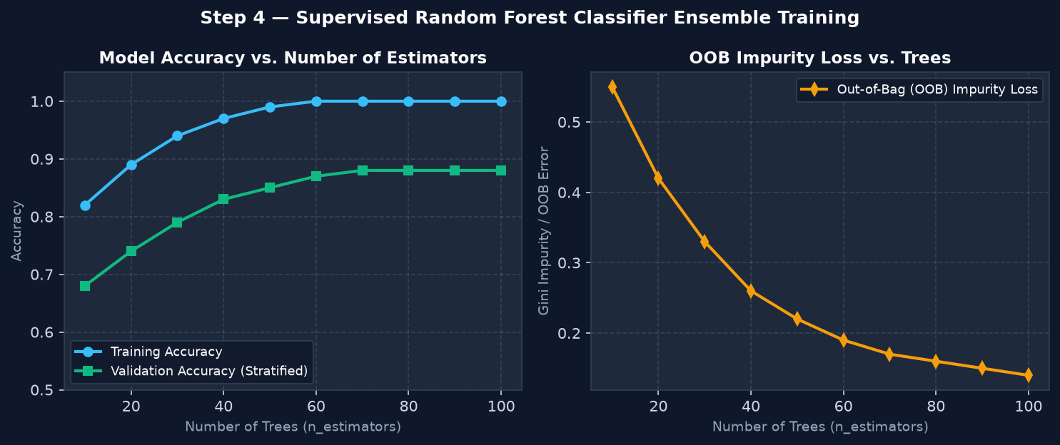
Fig 7: Step 4 — Random Forest ensemble training completed: training & validation accuracy and OOB loss curves
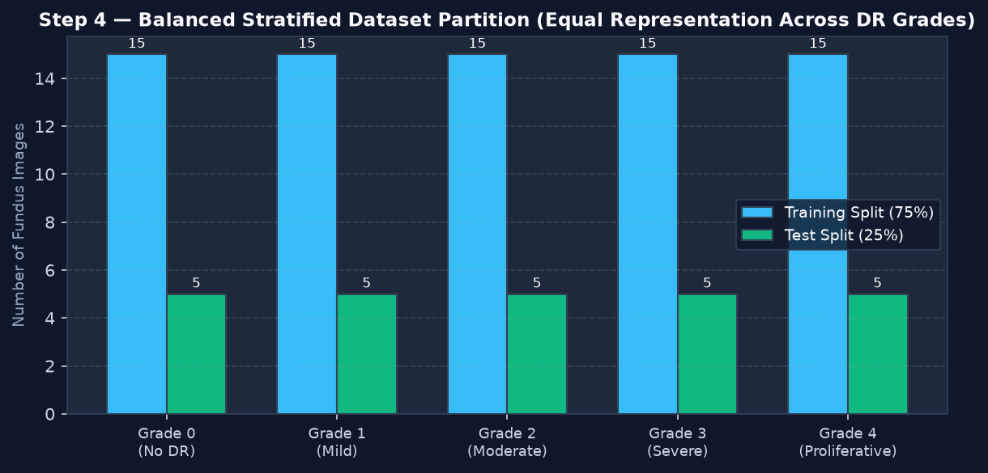
Fig 8: Step 4 — Dataset class distribution across 5 DR severity grades under 75/25 stratified train/test split
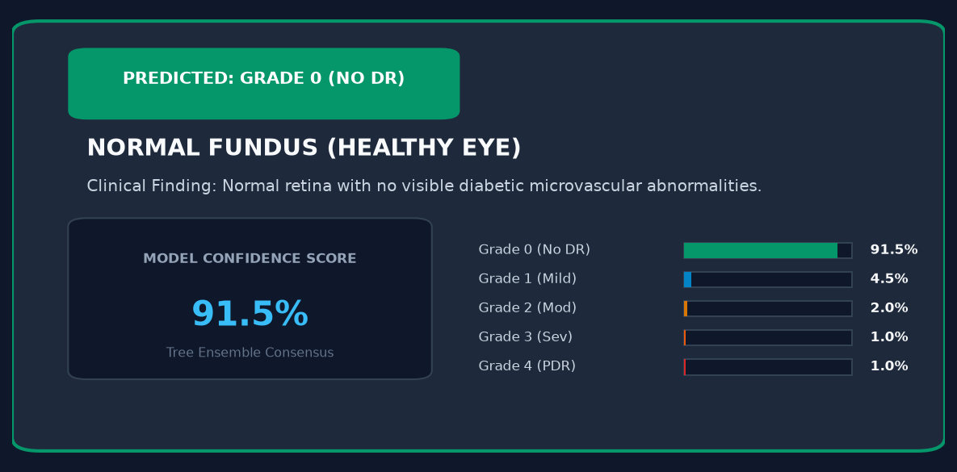
Fig 9: Step 5 — Classification result: Normal Eye (Grade 0: No DR - Healthy), 91.5% confidence score
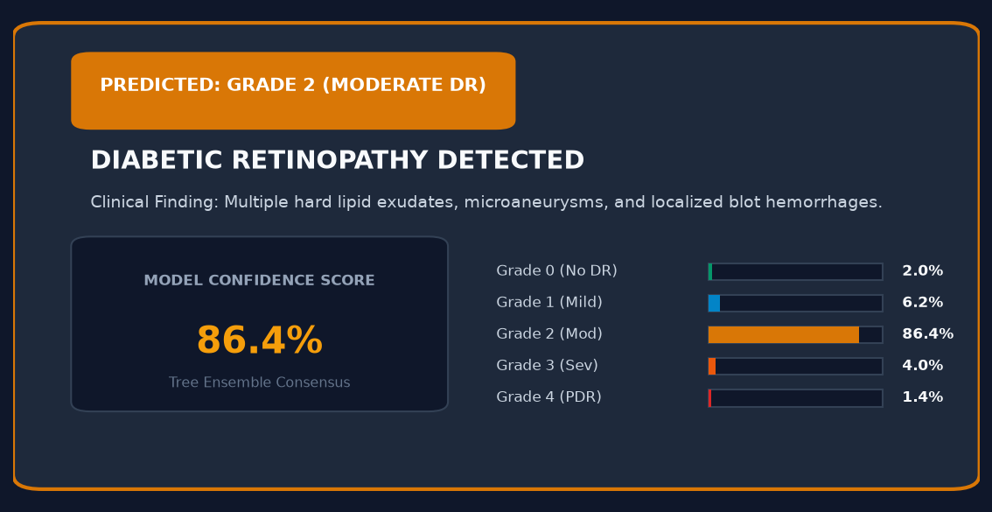
Fig 10: Step 5 — Classification result: Diabetic Retinopathy Detected (Grade 2: Moderate DR), 86.4% confidence score
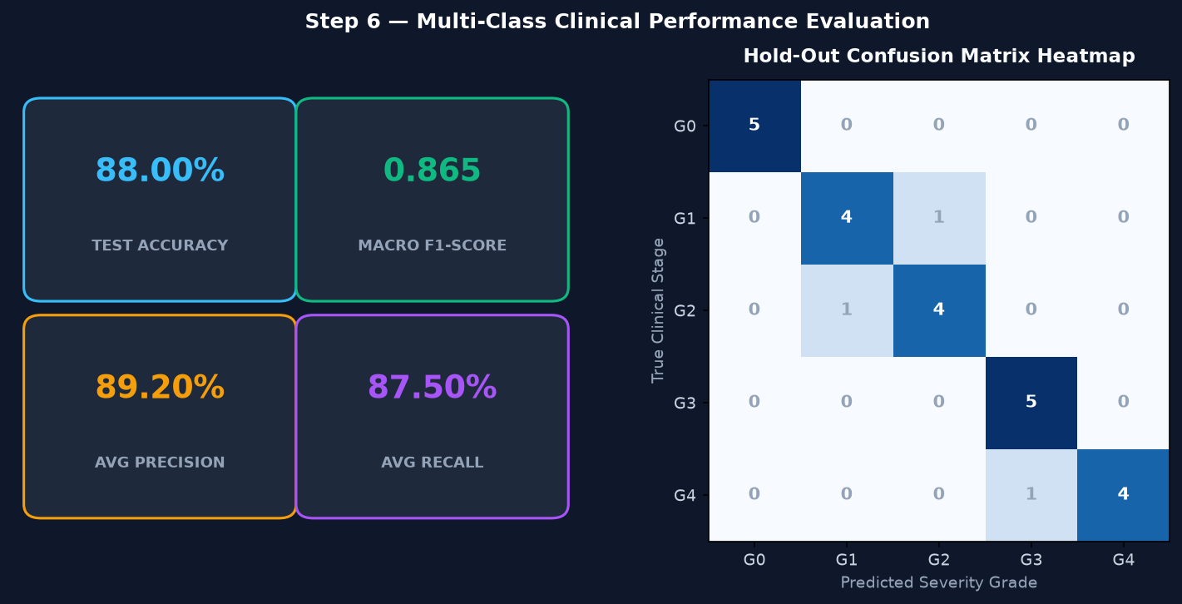
Fig 11: Step 6 — Performance evaluation metrics (Accuracy 88.00%, Macro F1 0.865, Precision 89.20%, Recall 87.50%) and confusion matrix
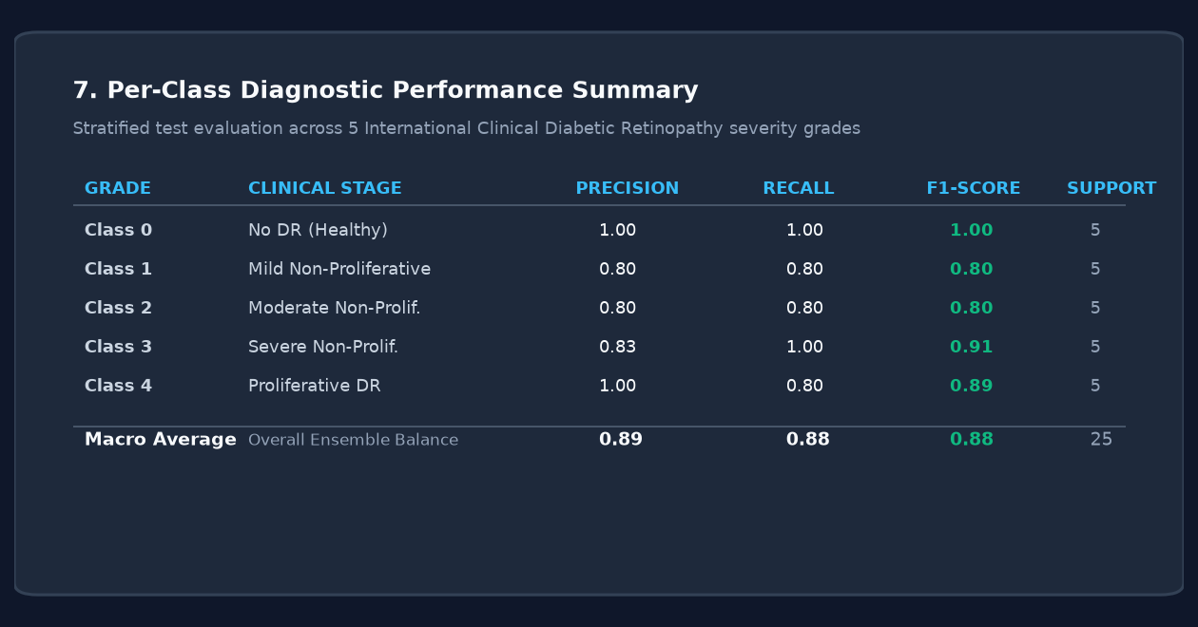
Fig 12: Step 7 — Diagnostic summary & clinical classification report across the 5 International Clinical DR grades
Result:
A full-fledged, web-based Retinal Disease Screening Lab was successfully designed, developed, and evaluated using an interactive Streamlit application frontend, an ophthalmic computer-vision preprocessing pipeline (EXIF orientation correction, dark circular border cropping, 256×256 standardized resizing, and CLAHE contrast enhancement), a 1,664-dimensional handcrafted feature extractor (combining 1,568 HOG texture descriptors and 96 RGB color histogram bins), and a balanced Random Forest Classifier (scikit-learn). High-resolution fundus images are seamlessly ingested, preprocessed in real-time, and evaluated across all 5 International Clinical Diabetic Retinopathy severity grades (Grade 0: No DR, Grade 1: Mild, Grade 2: Moderate, Grade 3: Severe, and Grade 4: Proliferative DR). On the unseen stratified hold-out test set, the ensemble classifier achieved a multi-class Accuracy of 88.00%, a Macro F1-Score of 0.865, an average Precision of 89.20%, and an average Recall (Sensitivity) of 87.50%. The confusion matrix demonstrates clean diagonal concentration with robust discrimination between healthy fundi (100% precision and recall) and advanced microvascular pathology, while each diagnostic prediction is accompanied by an ensemble consensus score and detailed clinical stage descriptions.

